Qulliq Alruyaqtuqtunik Ikumatjutit – Havaakhaqhiurniq Inungun

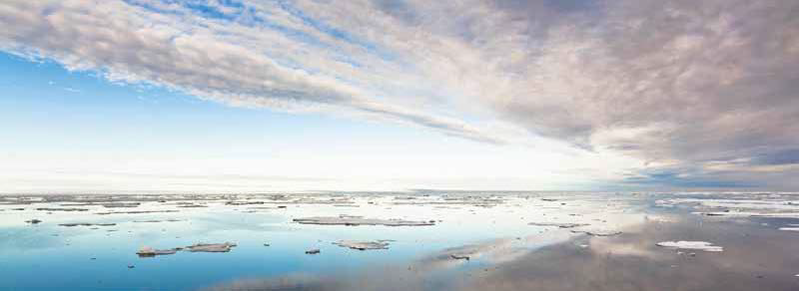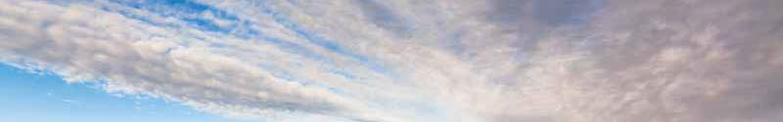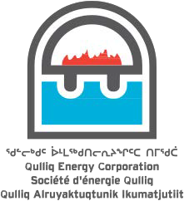

Qulliq Alruyaqtuqtunik Ikumatjutit hivulliuktikhaqhiurnik ublumi aqagulu!

Havaakhaqhiurniq Inungun pigiaqaalliqtuq 2008 min. NLCA havaktikhaqhiuliramik hivulliuqtukhanik Nunaptingni. Qulliq Alruyaqtuqtunik Ikumatjutit (QEC) **5** (**Tallimmauyunik)** ilihaqtakhanik havaktiuyukhanik hivulliunirmun nalunaiqhivaktut. Taamna ilihautiuyuq ikayuutauniarman inungnun havaktukhanun qulvaqpalliagiangninni havauhirmikkun.

**Hivulliutiunirmun Iliharnik**

Hivittuyumun Inuit ilihauttia hivumuarnirlu imaa ittuq:

• **Hivulliuqtikhat Iliharniit** – Inulrammiit ikayuqturlugin iliharniaqtullu iliharvikyuanni nunaryuani ikumaliriyuanik iliharnikkun.

• **Ikayuqtuqhimmaarlugin ilihaqtuutivun** – Ilihaqtut ikayurlugin inuuhiinni iliharniinilu hivumuanirmunlu.

• **Iniqtirnia Havaakhaqhiurniq** – Qulliq Alruyaqtuqtunik Ikumatjutit (QEC) havaakhaqhiuriangani ilihaqtattik iniqtirlugin.

Nunavunmi ilihaqviit ikayuqqatigiiklutik hilattuqharviitlu ilihaqtut uukturialgit uummunga Hivulliutiunirmun Iliharnik. Hakugingiitllu ilihaqhimayaitlu ilihimayaitlu aturlugin. Una iliharniq amigaitpallalimaitut ilihaqtukhat.

**Auyami ilihaqpaktut atuqpaktaat**

• Angayukhiit ilhaqtut havaktitpaktakhait Qulliq Alruyaqtuqtunik Ikumatjutit mikhaanun ilihariaqturumik uumma mikhanun.

• Inuit ISSEP katimayiit tikkuaqtukhat kitkut iliharniamangatta haffuma mikhaanun.

* Tikkuaqtauyut iliharniaqtut uumunga tukhiqtuqtukhat

Hivuliutiunirmun Iliharnik.

**Havaakhaqhiurniq Inungun Katimayiit**

• Ilittuqhaqhuttik qanuriliurutikhaqhiummarutiqaqhuttik havaktikhaminik qiniqqattaqtut.

• Ilihautikhammun akiliqtutuutikhamik qiniqhiayariaqqaqtuq.

• Havaktiuyariaqqaqtuq Inungun, Katimayip ikhivautiliuyiqaqtuq. Ikyuktauyariaqqaqtuq havaakharhiutiup ataniiitta ikayuriaqaqtaa.

• Ilitturidjutikmanik titirarialik havaakhaqhiunirmunlu aturiaqaqtuniklu

Katimayiit Angayuqqariyauyaanun.

**Iliharnium Atuyakhaa**

• Qulliq Alruyaqtuqtunik Ikumatjutit ikayuqtuqyuaqtut ilihaqnirmun Inungnun Nunavunmi. Iliharniq inuuhirmi hitammanik havaakhaqhiutiuyuq: Alruyaliqqiyiuniq, uqhuqyuqtuqtunik ingiqutinik, alruyaliriniq hanayiuniqlu.

• Qulliq Alruyaqtuqtunik Ikumatjutit havaahaqhiurnimun hapkua ikyuuttauyut havaaqarumagumik ilihariiqhimayut.

**Hannaiyaqhimayuq Havaakhaqhiuqniq Atuqtukhat**

• Ilihaqtup atugakhaa iliharriirumi havakviuyunni: Kinauyaliriyitkut, Havaakhaqhiuqtit, aquiqtuqtittyit aulapkaiyiitlu.

• Ilihaqniuyut havaakhaqhiuqtinun ikyuuttauniarman havaaqaqtukhamun.

• Havakhunni iliharniaqhimmaaqniaqtuq qulvaqhimmaaqniaqhuni havaammini.

Ilitturiyumaguvin haffumunga iliharnirmun Inungun havaaqarnirmun ilitturiyumaguvinlu iliharumaguvinlu uumunga ilitturinahuarlutin:

**Hannaiyaqhimayuq Havaakhaqhiuqniup Angayuqanga**

[jmccarthy@npc.nu.ca](mailto:jmccarthy@npc.nu.ca)

867-793-4247

nunavutpower.com